**Peatlands as nature-based solutions in Uganda’s NDC – key action points**

Peatland emissions are estimated at 1.2 Mt CO2 eq. in 2015 and projected to reach 7.1 Mt CO2 eq in 2030, i.e. equivalent to 6 % of the total emissions from the AFOLU sector in 2030. Rewetting of half of the peatlands by 2025 would lead to annual avoidance of 3.55 (Mt CO2 eq.) in 2030, i.e. equivalent to 4.3 % of the total emissions reduction of the AFOLU sector. Rewetting of all drained peatlands by 2025 would lead to annual avoidance of 7.1 (Mt CO2 eq.) in 2030, i.e. equivalent to 8.6 % of the total emissions reduction of the AFOLU sector.

*Referring to NDC Draft 3.0, shared by the MoWE on 2021/10/18*

|  |  |
| --- | --- |
| Intervention/suggestion point | page |
| 4 Mitigation component of the NDC: 4.1 Baseline | |
| Figure 4.2: We suggest to include the peatlands in the Baseline scenarios here. It can increase the AFOLU sector’s overall emission reduction potential See Table at the end of the Fact sheet. | 39 |
| Peatlands should be merged with Wetlands management in Table 4.2 as they are part of the Wetlands management activity, with special reference to the peatland map available from the NBI report (Please refer to IPCC 2014; Elshehawi et al. 2019). | 42 |
| The following text includes the most up to date and correct numbers for the mitigation potential from peatlands rewetting (See 4.2.2.):  “Peatland emissions are estimated at 1.2 Mt CO2 eq in 2015 and would reach 7.1 Mt CO2 eq in 2030, i.e. equivalent to 6 % of the total emissions from the AFOLU sector in 2030. Rewetting of half of the peatlands by 2025 would lead to annual avoidance of 3.55 (Mt CO2 eq.) in 2030, i.e. equivalent to 4.3 % of the total emissions reduction of the AFOLU sector. Rewetting of all drained peatlands by 2025 would lead to annual avoidance of 7.1 (Mt CO2 eq.) in 2030, i.e. equivalent to 8.6 % of the total emissions reduction of the AFOLU sector.” | 42 |
| Please use the correct unit (Mt CO2 **eq**.) used in the calculations made in our report, as it includes also CH4 and N2O, unlike the unit used (Mt CO2) currently in section 4.2.2. | 42 |

* *Peatland Map of Uganda to be included in NDC:*

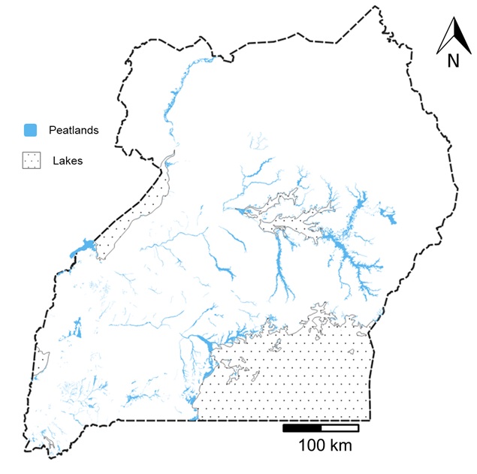

* NDC and BAU baseline trajectories updated with emissions from drained peatlands (wetlands with organic soils):

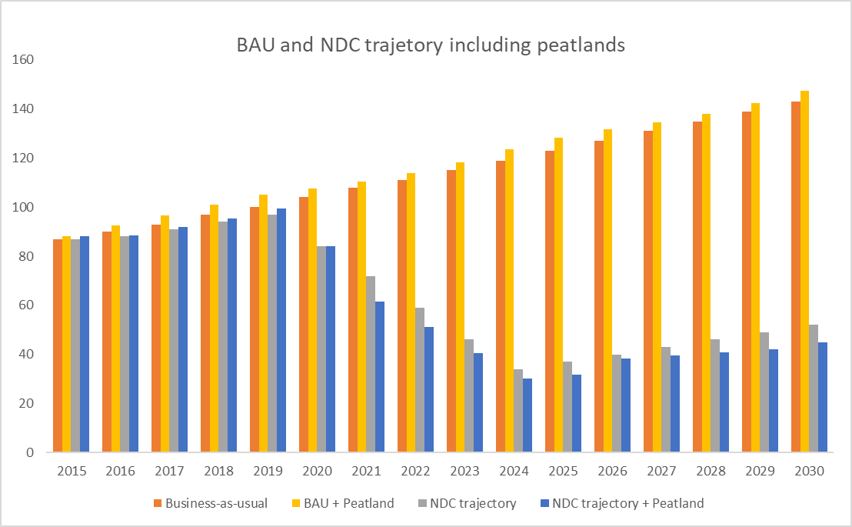

|  |  |  |  |  |  |  |  |  |  |  |  |  |  |  |  |  |
| --- | --- | --- | --- | --- | --- | --- | --- | --- | --- | --- | --- | --- | --- | --- | --- | --- |
| Trajectory | 2015 | 2016 | 2017 | 2018 | 2019 | 2020 | 2021 | 2022 | 2023 | 2024 | 2025 | 2026 | 2027 | 2028 | 2029 | 2030 |
| Business-as-usual | 87 | 90 | 93 | 97 | 100 | 104 | 108 | 111 | 115 | 119 | 123 | 127 | 131 | 135 | 139 | 143 |
| NDC trajectory | 87 | 88 | 91 | 94 | 97 | 84 | 72 | 59 | 46 | 34 | 37 | 40 | 43 | 46 | 49 | 52 |
| BAU + Peatland | 88 | 92 | 97 | 101 | 105 | 108 | 110 | 114 | 118 | 124 | 128 | 132 | 134 | 138 | 142 | 148 |
| NDC trajectory + Peatland | 88 | 89 | 92 | 95 | 99 | 84 | 62 | 51 | 41 | 30 | 32 | 38 | 39 | 41 | 42 | 45 |

**References**

Elshehawi, S. et al. (2019) assessment-of-carbon-co2-emissions-avoidance-potential-from-the-nile-basin-peatlands. https://nilebasin.org/information-hub/technical-documents/83-assessment-of-carbon-co2-emissions-avoidance-potential-from-the-nile-basin-peatlands/file